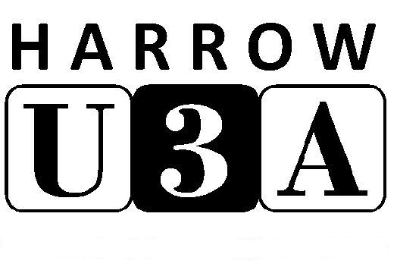Harrow U3A Membership Renewal
For the year 1 Oct 2019 - 30 Sep 2020
For office use only:

Received ……………………….

Cheque amt £………..

Signed by:……………………....

Info to database………………

Sticker sent ……………..……

Cheque to treasurer ………….
Harrow U3A is a registered charity, No 1009872
and a member of the Third Age Trust**
Please print clearly in blue or black pen, and fill in both sides of the form
Member details
Title: Mr/Mrs/Miss/Ms/Dr/etc Membership number
Forename Surname
email
Address

Postcode Phone – landline mobile

Second member at the same address?
Title: Mr/Mrs/Miss/Ms/Dr/etc Membership number
Forename Surname
Email mobile

MEMBERSHIP FEES: Please tick which one applies
Individual member £55 Joint - Two members at the same address £100

Reduced rate for member(s) receiving Pension Credit £12 per person, DWP no. ………………………….
2nd person, DWP no. …………………..………
**These fees include a £3.50 membership fee paid to our national organisation, the Third Age Trust, which provides a wide range of services and benefits, including liability insurance cover.

I enclose a cheque made out to Harrow U3A for £……………

Name of cheque signatory (please print clearly) ………………………………………………………..........

TERMS AND CONDITIONS OF MEMBERSHIP
All members must:
- Abide by the Principles of the U3A movement.
- Always act in the best interests of the U3A and never do anything to bring the U3A into disrepute.
- Abide by the terms and conditions of the constitution and policies (*see over)
- Treat fellow members with respect and courtesy at all times
- Comply with and support the decisions of the elected committee.
- Advise the committee of any change in your personal details.
- Abide by the Member Code of Conduct (*see over)

I/We apply to renew my/our membership of Harrow U3A and confirm that I/we will abide by the terms of membership as stated above. I/We confirm that I/we have completed the form myself/ourselves or have been assisted to do so.
Signed Date
……………………………………………………………………………………………………………………. ……………………………………………..
2nd member
………………………………………………………………………………………………………………….. ………………………………………………

PRIVACY STATEMENT*
Harrow U3A processes member information so that we can keep you informed about events, groups and activities as part of your membership. In processing your information Harrow U3A will:
- Store it securely;
- Use it to communicate with you as a U3A member;
- Share your information with group leaders for those groups that you are a member of;
- Send you general information about the Third Age Trust**

*Harrow U3A’s lawful basis for collecting this information is legitimate interest. You can see our constitution, data protection and privacy policies, and the member code of conduct, on our website, www.harrowu3a.co.uk, or contact the Hon Secretary at 5 Furham Feild, Hatch End, Pinner, HA5 4DX to request a paper copy.
**The Third Age Trust is the national organisation to which all U3As are affiliated.

Optional
As a registered charity, Harrow U3A can claim Gift Aid on your subscription, if you are a UK taxpayer. This increases our income (so keeps membership fees as low as possible) at no cost to you.
Please tick this box if you would like us to send you a Gift Aid Declaration form (unless you have already done so – in which case, thank you, and there’s no need to fill in another one).

All members of Harrow U3A receive a printed newsletter once a term which includes details of all our activities. We also have an email news group, to inform you between newsletter editions when there are new groups and outings, or late changes, vacancies, cancellations, etc.
Please tick this box if you would like to receive email news from HU3A

The Third Age Trust also produces a magazine – Third Age Matters - for U3A members. If you would like to receive this magazine (at no extra cost to you) please tick this box.
I consent to my name and address data being shared with the company who oversee the distribution of the Trust Magazine

HU3A currently stores year of birth data for those members who have supplied it. It is used to provide an age profile
of our membership, which helps our planning. Please tick this box if we may continue to use it in this way.

Please be advised that you can request that your data not to be used for any of these optional purposes by contacting the Membership Secretary (contact details in the Harrow U3A newsletter).

Harrow U3A is a self-help organisation, run by the members for the members. We have a wide range of study groups, and as a member you can attend as many as you want. However, if you are interested in a subject we don’t at present offer, if a current group you wish to join has no vacancies or if you would consider helping to run a group (or in some other way), please tell us and we will try to start a new group.
Please let us know your interests/suggestions/offers of help

Please post to: Membership Secretary, 68 Pinner Court, Pinner, HA5 5RN:
this form, completed and signed
your cheque, made payable to Harrow U3A
a stamped, self-addressed envelope for us to post back the sticker for your card. If you have
lost your membership card, please tell us here:
.......................................................................................………………………………………………………………………………
Enquiries: email: membership.hu3a@yahoo.co.uk Phone: 020 8422 9895
Please be aware that renewal time is very busy for the membership team, so there may be a delay in dealing with your form. All our Committee and Group Leaders are volunteers, so please only contact them during normal office hours.

